**Cloud Computing**

**UE19CS352**

**6th Semester, Academic Year 2021-22**

Assignment #: 4 Raft

Date: 28/3/2022

|  |  |  |
| --- | --- | --- |
| Name :  SUMUKH RAJU BHAT | SRN :  PES1UG19CS519 | Section :  H |

1-a.jpg:

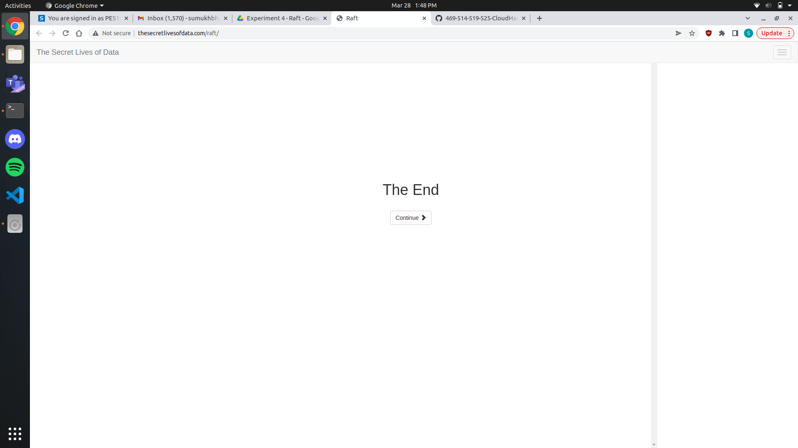

1-b.jpg:

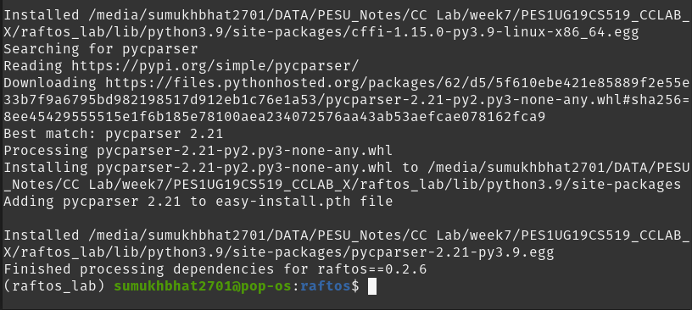2_a.jpg:

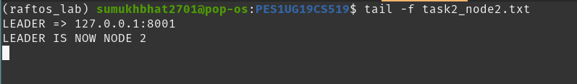

2_b.jpg:

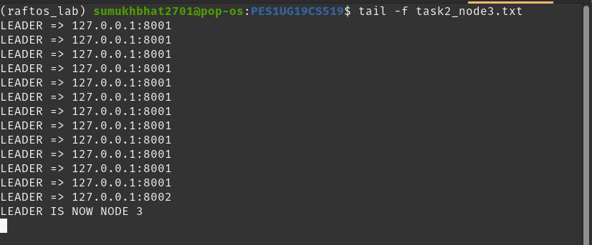

2_c.jpg:

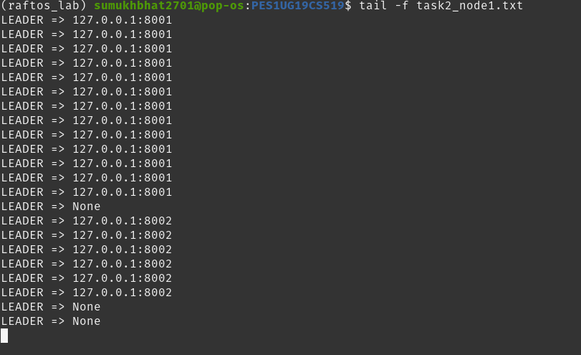

3_a.jpg:

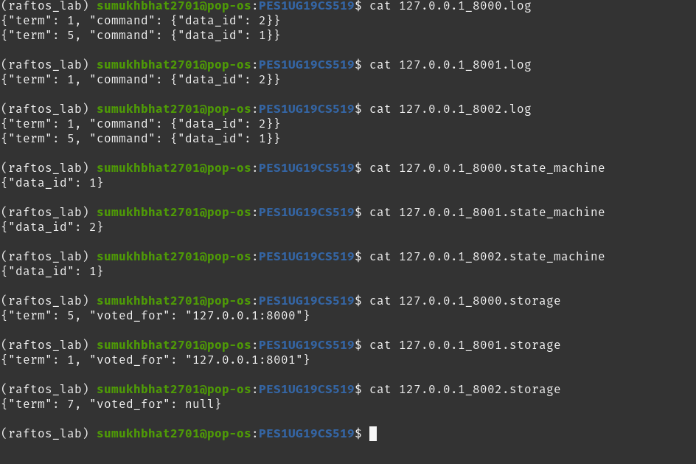

3_b.jpg:

